***EXERCISE 1: CREATE A SPRING WEB PROJECT USING MAVEN***

**SpringLearnApplication.java:**

package com.cognizant.spring_learn;

import org.springframework.boot.SpringApplication;

import org.springframework.boot.autoconfigure.SpringBootApplication;

@SpringBootApplication

public class SpringLearnApplication {

public static void main(String[] args) {

SpringApplication.run(SpringLearnApplication.class, args);

// 👇 Output statements

System.out.println("========================================");

System.out.println("✅ Spring Boot Application Started");

System.out.println("🌐 Try opening: http://localhost:8080");

System.out.println("========================================");

}

}

**OUPUT:**

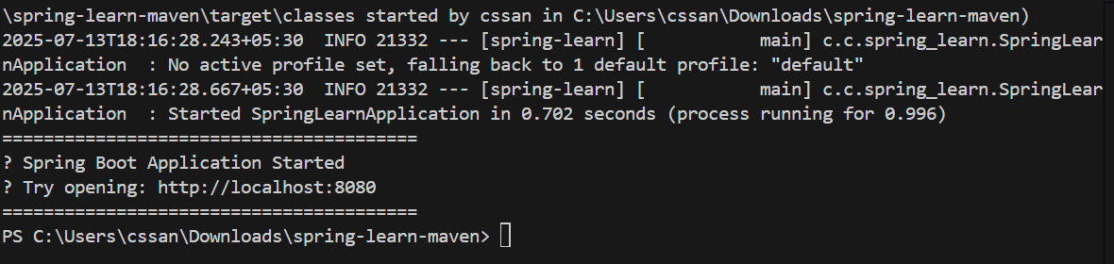

***EXERCISE 2: SPRING CORE – LOAD COUNTRY FROM SPRING CONFIGURATION XML***

**SpringLearnApplication.java:**

package com.cognizant.spring_learn;

import org.springframework.context.ApplicationContext;

import org.springframework.context.support.ClassPathXmlApplicationContext;

public class SpringLearnApplication {

public static void main(String[] args) {

displayCountry();

}

public static void displayCountry() {

ApplicationContext context = new ClassPathXmlApplicationContext("country.xml");

Country country = (Country) context.getBean("country", Country.class);

System.out.println("Country: " + country.toString());

}

}

**OUTPUT:**

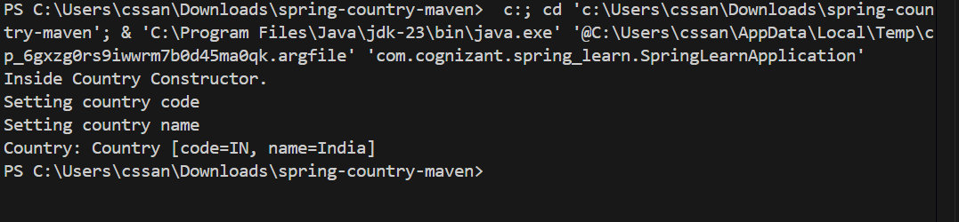

***EXERCISE 3: HELLO WORD RESTful WEB SERVICES***

**HelloController.java:**

package com.cognizant.springlearn.controller;

import org.slf4j.Logger;

import org.slf4j.LoggerFactory;

import org.springframework.web.bind.annotation.GetMapping;

import org.springframework.web.bind.annotation.RestController;

@RestController

public class HelloController {

private static final Logger LOGGER = LoggerFactory.getLogger(HelloController.class);

@GetMapping("/hello")

public String sayHello() {

LOGGER.info("START - sayHello()");

String response = "Hello World!!";

LOGGER.info("Returning Response: {}", response);

LOGGER.info("END - sayHello()");

return response;

}

}

}

**OUTPUT:**

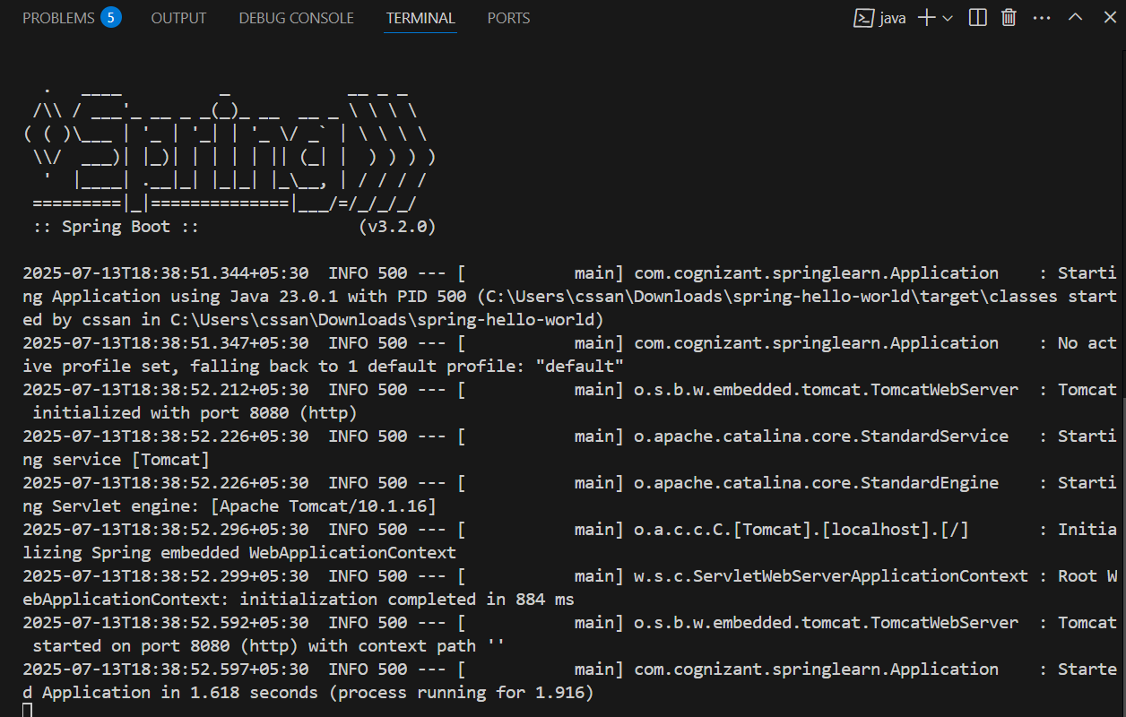

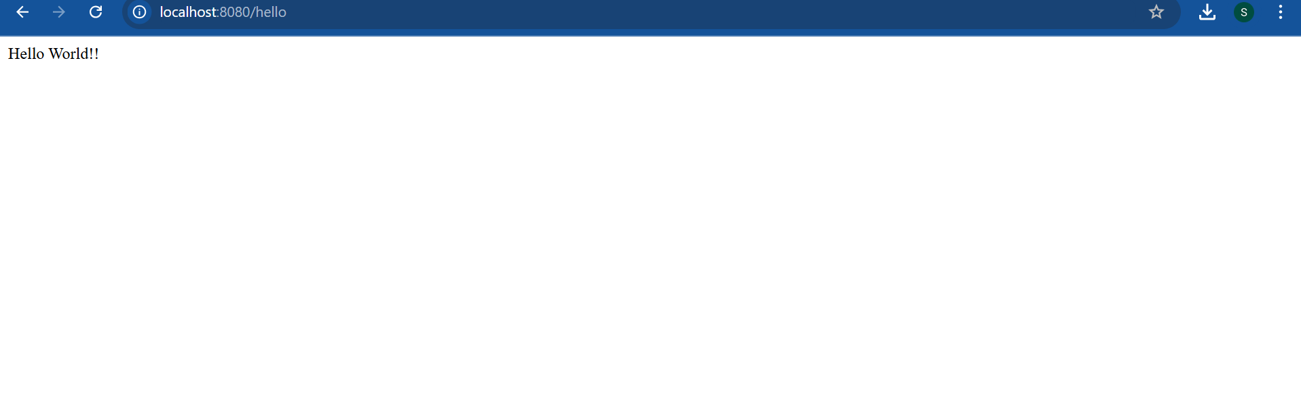

***EXERCISE 4: REST – COUNTRY WEB SERVICES***

**CountryController.java:**

package com.cognizant.springlearn.controller;

import com.cognizant.springlearn.model.Country;

import org.slf4j.Logger;

import org.slf4j.LoggerFactory;

import org.springframework.context.ApplicationContext;

import org.springframework.context.support.ClassPathXmlApplicationContext;

import org.springframework.web.bind.annotation.GetMapping;

import org.springframework.web.bind.annotation.RestController;

@RestController

public class CountryController {

private static final Logger LOGGER = LoggerFactory.getLogger(CountryController.class);

@GetMapping("/country")

public Country getCountryIndia() {

LOGGER.info("START - getCountryIndia()");

ApplicationContext context = new ClassPathXmlApplicationContext("country.xml");

Country country = (Country) context.getBean("in");

LOGGER.info("END - getCountryIndia()");

return country;

}

}

**OUTPUT:**

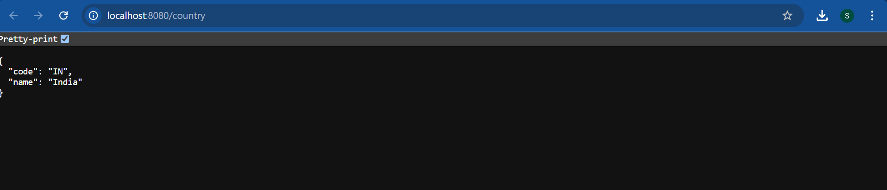

***EXERCISE 5: GET COUNTRY BASED ON COUNTRY CODE***

**Application .java:**

package com.cognizant.springlearn;

import org.springframework.boot.SpringApplication;

import org.springframework.boot.autoconfigure.SpringBootApplication;

@SpringBootApplication

public class Application {

public static void main(String[] args) {

SpringApplication.run(Application.class, args);

}

}

**OUTPUT:**

